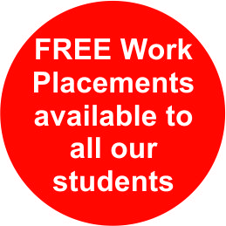


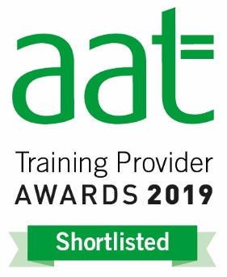
SHORT COURSES TRAINING APPLICATION FORM
PERSONAL DETAILS
Surname |  | First Names
Address

Tel No (daytime) |  | Tel No (evening)
E-Mail address |  | Gender
Date of Birth |  | Nationality & Ethnicity
PREVIOUS QUALIFICATIONS/ TRAINING/ EXPERIENCE

Previous Course(s) | Date |  | Details
PLEASE STATE WHERE YOU FIRST HEARD ABOUT THIS TRAINING
COURSES (Please tick the dates/trainings/work experience you wish to attend)
Sage 50 Computerised Accounts Level 1 & 2- 2 days per session
[ ] £250 training & work experience; [ ]£150 –training only; [ ] £250 Work experience only
[ ] 14th – 15th November 2019 [ ] 18th - 19th December 2019
[ ] 17th – 18th January 2020 [ ] 19th – 20th February 2020

Sage 50 Computerised Accounts Level 3- 2 days per session
[ ] £250 training & work experience; [ ]£150 –training only; [ ] £250 Work experience only
[ ] 20th – 21st November 2019 [ ] 28th – 29th February 2020
[ ] 04th – 05th June 2020 [ ] 26th – 27th August 2020

Sage Payroll Training- 3 days training
[ ] £300 training & work experience; [ ]£200 –training only; [ ] £250 Work experience only
[ ] 12th-14th December 2019 [ ] 28th – 30th January 2020
[ ] 16th – 18th April 2020 [ ] 29th – 31st July 2020

Management Accounts Training – 2 days per session
[ ] £250 training & work experience; [ ]£150 –training only; [ ] £250 Work experience only
[ ] 08th – 09th November 2019 [ ] 12th – 13th February 2020
[ ] 13th – 14th May 2020 [ ] 14th – 15th August 2020

Excel Spreadsheet Training- 2 days per session
[ ] £250 training & work experience; [ ]£150 –training only; [ ] £250 Work experience only
[ ] 28th – 29th November 2019 [ ] 23rd - 24th January 2020
[ ] 22nd – 23rd April 2020 [ ] 23rd – 24th July 2020

VAT Training – 2 days per session
[ ] £250 training & work experience; [ ]£150 –training only; [ ] £250 Work experience only
[ ] 06th – 07th November 2019 [ ] 20th – 21st January 2020

CV & Interview Session 1 day 10am – 2pm [ ] £100 per session
[ ] 24th April 2020 [ ] 6th November 2020

**BUNDLE OFFERS**
Bundle 1:
Book any 2 short courses with work experience and get 5% discount + 1 extra month of work experience. (Total 5 months work experience – 1 day per week)

Bundle 2:
Book any 4 short courses with work experience and get 8% discount + 1 extra month of work experience. (Total 9 months work experience – 1 day per week)

Bundle 3:
Book all 6 short courses and get 10% discount in addition to your 12 months work experience + FREE CV & Interview sessions & FREE review of your CV + Possibility of doing 2 days per week for 6 months + other flexibilities

Additional Benefits:

- Opportunity for Accounting work placement with any of our trainings. The length of your work placement depends on the combination of trainings you attend.

- Develop employment skills while you study

- Opportunity to manage and supervise other trainees and develop management skills

- References available from the firm

- Please indicate with a tick if you are interested in obtaining a work experience at our partner firm St Mary’s Services (your work placement is guaranteed subject to us receiving two references for you.) [ ]
- Please note we operate on a strictly first come first served basis.
- £100 deposit is required to secure your booking on each course and is payable on application.
- The balance will be payable in cash, on arrival or by card before the start date of the training.
- Payments can be made by PayPal, Cards, Cheque, BACS or Cash (please do not send cash in the post).

- Cancellations, amendments and refunds are allowable up to ten working days prior to the start of the training session. After this date, we are unable to offer a refund.

Please return this application to admin@thetrainingplace.org or post to Carlton Cottages, 12 New Cross Road, London, SE14 5BE. If you have any questions, please contact 02072 529331 or 07958 216021.

